

**Physical Education Studies**

**Units 1 & 2**

**Sem 2 exam 2021**

# Marking Key

**Section One – Multiple Choice**

|  |  |
| --- | --- |
| **Question** | **Answer** |
| 1 | C |
| 2 | B |
| 3 | D |
| 4 | A |
| 5 | B |
| 6 | B |
| 7 | C |
| 8 | D |
| 9 | C |
| 10 | C |
| 11 | C |
| 12 | D |
| 13 | A |
| 14 | A |
| 15 | C |
| 16 | D |
| 17 | D |
| 18 | B |
| 19 | C |
| 20 | A |

**End of Section One**

**Section Two: Short answer 50% (60 marks)**

This section has **eight (8)** questions. Answer **all** questions. Write your answers in the spaces provided. Use a blue or black pen (**not** pencil) for this section.

Supplementary pages for the use of planning/continuing your answer to a question have been provided at the end of this Question/Answer booklet. If you use these pages to continue an answer, indicate at the original answer where the answer is continued, i.e. give the page number.

Suggested working time: 70 minutes.

________________________________________________________________________

**Question 21 (7 marks)**

Earlier this year, former Aquinas College student Logan McDonald made his AFL debut for the Sydney Swans against last year’s preliminary finalist, the Brisbane Lions.

Prior to the start of the game, Logan had to ensure that he was in the ideal performance state to be able to perform at his optimal level.

(a) Identify and explain the hypothesis that outlines the relationship between arousal and performance.

(3 marks)

|  |  |
| --- | --- |
| Description | Marks |
| Inverted U Hypothesis | 1 mark |
| When arousal is optimal, performance is at its best  When arousal is either above or below optimal, performance is negatively affected (or similar) | 1 mark  1 mark |

(b) Identify which state of arousal Logan was likely to be in for the start of the match.

(1 mark)

|  |  |
| --- | --- |
| Description | Marks |
| Over aroused | 1 mark |

(c) Explain **three** factors that have an influence on the optimal level of arousal of an athlete.

(3 marks)

|  |  |
| --- | --- |
| Description | Marks |
| Age – typically younger athletes are less skilled and therefore require a lower level of arousal (or similar) | 1 mark |
| Skill level – advanced player requires higher levels arousal  OR  novice requires low level of arousal | 1 mark |
| Activity type  Tasks which are hard or complex benefit from lower levels of arousal  OR  Tasks which are considered easy require higher levels of arousal | 1 mark |

**Question 22 (6 marks)**

Complete the table below identifying the key properties for the three types of muscle fibres.

|  |  |
| --- | --- |
| Description | Marks |
| No half marks – must have both correct responses for each muscle fibre to receive 1 mark | 1-6 marks |

|  |  |  |  |
| --- | --- | --- | --- |
| Property | Muscle fibre types | | |
| Type l | Type lla | Type llb |
| Fibre diameter |  | Intermediate | Large |
| Force production | Low |  | Very High |
| Contractile speed | Slow | Fast |  |
| Major fuel source | Triglycerides and Glycogen |  | Creatine Phosphate and Glycogen |
| Mitochondrial density | High |  | Very Low |
| Activity used for | Endurance sports  (any relevant example) | Sprint endurance  (any relevant example) |  |

**Question 23 (9 marks)**

(a) Outline **two** structural differences that exist between arteries and veins.

(2 marks)

|  |  |
| --- | --- |
| Description | Marks |
| Any 2 of the following   * Arteries are larger than veins/have thicker walls * Arteries are more elastic than veins * Veins have valves whereas arteries do not have any valves | 1-2 marks |

(b) The capillaries that surround muscles are crucial to the exchange of gases, fuels and wastes. Discuss how a concentration gradient allows for effective gas exchange to take place at the capillary/muscle interface.

(2 marks)

|  |  |
| --- | --- |
| Description | Marks |
| Oxygen moves from high concentration in the capillaries to low  concentration in the muscle tissue | 1 mark |
| Carbon Dioxide moves from high concentration in the muscle  tissue to low concentration in the capillaries | 1 mark |

(c) Ben Simmons will often take a deep breath through his nose before focusing on shooting a free throw shot at the line. Describe the mechanics of the diaphragm and the intercostal muscles during inhalation and how air is able to enter the lungs.

|  |  |
| --- | --- |
| Description | **Max 3 Marks** |
| Contraction of diaphragm causes muscle sheet to flatten and increase volume of chest. | 1 mark |
| The intercostal muscles contract drawing the rib cage up and outwards which increases the volume in the chest. | 1 mark |
| The increased chest volume reduces air pressure inside the lungs. Pressure differential created (low pressure) relative to outside (high pressure) allows for the outside air to flow into the lungs. | 1 mark |

(d) During lockdown earlier in the year, it was mandated that people wear masks whenever they left their home, except to exercise. Why would wearing a mask make exercising more difficult?

(2 marks)

|  |  |
| --- | --- |
| Description | Marks |
| The mask creates a barrier, resulting in less oxygen entering the lungs | 1 mark |
| As a result, less oxygen is delivered to the working muscles/diffused into the bloodstream | 1 mark |

**Question 24 (5 marks)**

A Year 11 Physical Education Studies student completes the 12-minute run test. She runs 7 ½ laps of a 400m running track with her start and finish points identified on the image below. Use this information to answer the following questions.

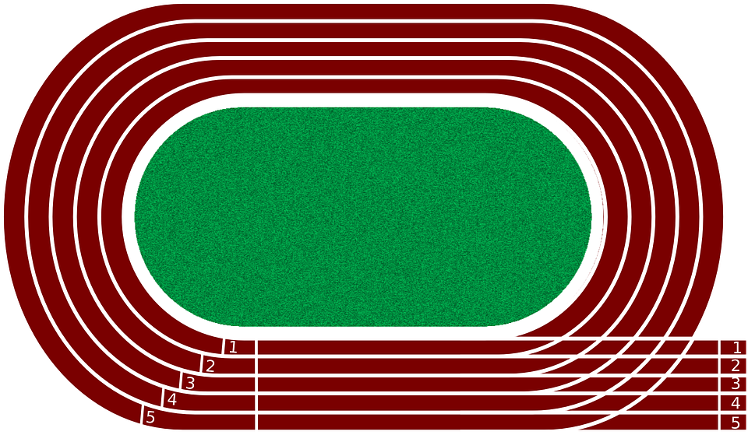

**Finish**

**150mm**

**Start**

(a) What was her displacement at the end of the 12 minutes?

(1 mark)

|  |  |
| --- | --- |
| Description | Marks |
| 150m | 1 mark |

(b) Would her displacement differ to her distance? Justify your response

(2 marks)

|  |  |
| --- | --- |
| Description | Marks |
| Yes | 1 mark |
| Distance represents how far in total you have travelled whereas displacement is your change in position/distance between where you started to where you finish in a straight line | 1 mark |

(c) How would you calculate her average speed?

(1 mark)

|  |  |
| --- | --- |
| Description | Marks |
| speed = distance/time | 1 mark |

(d) How would you calculate her average velocity?

(1 mark)

|  |  |
| --- | --- |
| Description | Marks |
| velocity = displacement/time | 1 mark |

**Question 25 (8 marks)**

The table belowshows suggested target heart rate zones for various age groups.

|  |  |  |  |  |  |  |  |  |  |
| --- | --- | --- | --- | --- | --- | --- | --- | --- | --- |
| Percentage of Maximum Heart Rate | Target Heart Rate Zones (Beats per minute) | | | | | | | | |
| 95% | 200 | 190 | 181 | 171 | 162 | 152 | 143 | 133 |
| 85% | 179 | 170 | 162 | 153 | 145 | 136 | 128 | 119 |
| 75% | 158 | 150 | 143 | 135 | 128 | 120 | 113 | 105 |
| 65% | 137 | 130 | 124 | 117 | 111 | 104 | 98 | 91 |
| 55% | 116 | 110 | 105 | 99 | 94 | 88 | 83 | 77 |
| **Age** | **10** | **20** | **30** | **40** | **50** | **60** | **70** | **80** |

(a) Using the table, state the suggested heart rate values that a 40-year-old should work between to ensure they are in the correct target zone to improve their cardiorespiratory endurance.

(1 mark)

|  |  |
| --- | --- |
| Description | Marks |
| 117-153bpm | 1 mark |

(b) Explain why the suggested target zone for a 20-year-old is different to that suggested for a 40-year-old.

(3 marks)

|  |  |
| --- | --- |
| Description | Marks |
| Maximum heart rate = 220 – age, therefore as you age your maximum heart reduces | 1 mark |
| Target zones are worked out as a percentage of maximum heart rate – i.e. 65-85% of HR Max | 1 mark |
| The 20-year-old would have a higher maximum heart rate/higher target zone. **OR** the 40-year-old would have a lower maximum heart rate/lower target zone | 1 mark |

(c) Identify and explain **two** training methods an athlete could use to improve their cardiorespiratory endurance.

(4 marks)

|  |  |
| --- | --- |
| Description | Marks |
| Any 2 of the following   * Continuous training * **i**nvolves performing an activity, such as jogging, cycling or swimming, nonstop for a period of 20min or longer * Long interval training * Series of repeated bouts of exercise interrupted by pre - determined rest periods or lighter exercise. Work: rest ratio is 1:1 or greater * Fartlek training * a variation of continuous training, involves changes of intensitythroughout the training sessions. | 1 mark identify, 1 mark explain |

**Question 26 (8 marks)**

The arrow directions in the diagrams below show two types of isotonic muscle contractions.

(a) Which diagram shows a concentric contraction? Justify your answer.

(2 marks)

|  |  |
| --- | --- |
| Description | Marks |
| A / bicep curl | 1 mark |
| Concentric because muscle (bicep) shortens as it lifts the weight causing the movement. | 1 mark |

(b) Which diagram shows an eccentric contraction? Justify your answer.

(2 marks)

|  |  |
| --- | --- |
| Description | Marks |
| B / push up | 1 mark |
| Eccentric because the muscles (triceps) lengthen as they contract under tension to allow the downward phase of the press up to be controlled. | 1 mark |

(c) Using diagram A, identify the following:

(4 marks)

i) Agonist

|  |  |
| --- | --- |
| Description | Marks |
| Bicep | 1 mark |

ii) Origin of agonist

|  |  |
| --- | --- |
| Description | Marks |
| Scapula | 1 mark |

iii) Antagonist

|  |  |
| --- | --- |
| Description | Marks |
| Tricep | 1 mark |

iv) Insertion of antagonist:

|  |  |
| --- | --- |
| Description | Marks |
| Ulna | 1 mark |

**Question 27 (8 marks)**

In sumo wrestling, two people who are wearing nothing but a mawashi (loincloth), face each other in a dohyo (circular ring) and push, grapple, and try to throw each other. The one who forces their opponent to the ground or pushes them out of the ring is considered the winner.

(a) Throughout a sumo wrestling bout, the athletes will position their body in a variety of ways to improve their balance and stability. Outline **three** strategies a wrestler might use to make them more stable during a sumo bout.

(3 marks)

|  |  |
| --- | --- |
| Description | Marks |
| Lower their centre of gravity | 1 mark |
| Increase the size of their base of support OR increase the size of their base of support in the direction of the opponent | 1 mark |
| Position their line of gravity inside their base of support or position COG near edge of their base of support in the direction of the oncoming opponent | 1 mark |

(b)Define Momentum and applying this with your knowledge of Newton’s 2nd Law, explain how a smaller wrestler might be able to push their larger opponent out of the ring.

(3 marks)

|  |  |
| --- | --- |
| Description | Marks |
| Momentum is a measure of the amount of motion possessed by a moving body | 1 mark |
| If the smaller competitor has sufficient velocity to generate more momentum than the larger slower athlete | 1 mark |
| The greater momentum of the smaller athlete will displace the larger athlete Or the smaller competitor will apply sufficient force to displace the larger athlete | 1 mark |

(c)At the 2012 London Olympic Games, new starting blocks were introduced, as shown in the image below (lanes 8 and 9). By comparison with previous blocks (lane 6 and 7), the new blocks have a raised lip at the rear.

Using Newton's 3rd Law, explain how changes to starting blocks have resulted in quicker start times in swimming.

(2 marks)

|  |  |
| --- | --- |
| Description | Marks |
| Newtons 3rd law states that every action has an equal and opposite reaction | 1 mark |
| Therefore, changes to starting blocks have allowed athletes to apply more force backwards which results in a greater equal and opposite reaction force forward, rather than vertical. | 1 mark |

**Question 28 (9 marks)**

Fitts and Posner proposed the skill learning continuum occurs across three (3) progressive stages:

1. The Cognitive Phase

2. The Associative Stage

3. The Autonomous Stage

Each stage is characterised by the individual demonstrating different attributes. Complete the table below to highlight these.

|  |  |
| --- | --- |
| Description | Marks |
| 1 mark each correct response | 1-9 marks |

|  |  |  |  |
| --- | --- | --- | --- |
|  | **Cognitive Stage** | **Associative Stage** | **Autonomous Stage** |
| Type of feedback | Extrinsic augmented | Combination of extrinsic augmented and intrinsic | * Mainly Intrinsic as athlete can self-correct * Very specific feedback when provided by extrinsic source |
| Cue recognition | Little, if no cue recognition | Some relevant cue recognition | Attends only to relevant cues with improved decision making |
| Consistency of performance | Very inconsistent from one attempt to the next | Moderate levels of consistency | High levels of consistency/low levels of variability in performance |
| Size and frequency of errors | Large size and frequency of errors | Moderate size and frequency of errors | Very low size and frequency of errors |

**End of Section Two**

**Section Three: Extended answers 30% (30 marks)**

This section contains **four (4)** questions. You must answer **two (2)** questions. Write your answer in the spaces provided.

Supplementary pages for the use of planning/continuing your answer to a question have been provided at the end of this Question/Answer booklet. If you use these pages to continue an answer, indicate at the original answer where the answer is continued, i.e. give the page number.

Suggested working time: 50 minutes.

**Question 29 (15 marks)**

In 2019 Kenyan marathoner Eliud Kipchoge became the first human to run a marathon in under two hours, covering the 42km distance in 1 hour, 59 minutes and 40 seconds. The run, organised specifically for Kipchoge to break the two-hour marathon barrier, and featured an electric pacer car that shot a laser beam to mark the best position on the road.

(a) A key component of the event was Kipchoge’s nutritional plan. Discuss what this nutritional plan would have involved before and during the event to ensure he had sufficient nutrients and energy to fuel the race.

(9 marks)

|  |  |
| --- | --- |
| Description | Marks |
| Before the event   * Athletes should consume 10 – 12 g of carbohydrate per kg of body mass to carbohydrate load effectively (or other relevant consumption guidelines) * Low GI foods/carbohydrate are used to carbohydrate load. * CHO loading combined with exercise taper to top up glycogen supplies * Maintain fluid intake to ensure optimal hydration | Max 3 |
| Pre event meal (1-4 hrs before)   * Approx. 600ml of fluid to assist with hydration * Low GI meal to top up glycogen supplies * Avoid high fibre foods and/or avoid high fat foods. | 1-3 |
| During the event   * 200ml of fluid every 15 - 20min * 30-60 g of CHO per hour * Carbohydrate should be high GI. * Avoid high fibre foods and/or avoid high fat foods. * Ingest electrolytes to decrease cramps/dehydration. | Max 3 |

(b) Discuss the term energy system interplay as it relates to an athletics sprint event like the 400m (approximately 50 sec duration).

(6 marks)

|  |  |
| --- | --- |
| Description | Marks |
| At the commencement of the race, all 3 energy systems start contributing to the production of ATP at the same time. | 1 mark |
| In the early stages of physical activity (0–5 sec), the ATP–CP system makes the most significant contribution as it can produce ATP at the fastest rate, however, runs out shortly after | 1 mark |
| When this system begins to deplete (at about the 5–6 sec mark) | 1 mark |
| the Anaerobic Glycolysis system begins to take over as the dominant provider of ATP. | 1 mark |
| It remains the dominant provider until about the 30 sec mark. | 1 mark |
| At this point the Aerobic system starts to produce ATP at a rate which meets the bodies demands for ATP and therefore becomes the dominant provider of ATP for the remainder of the race | 1 mark |

**Question 30 (15 marks)**

Pictured below are three (3) different sporting activities.

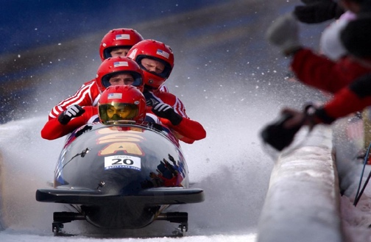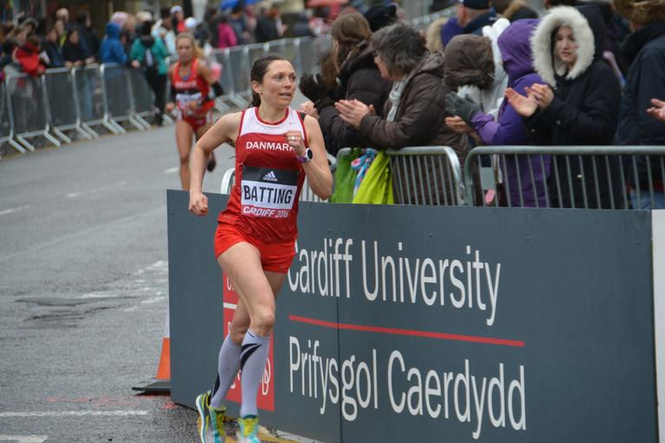

Image A – Bobsleigh Image B – Runner Image C – gymnast on horizontal bar

(a) Identify and describe **three** different types of motion. Include an example of each type of motion from the pictures above (note – each image can only be used once)

(9 marks)

|  |  |
| --- | --- |
| Description | Marks |
| Linear Motion  Describe: Where movement is along a straight line, there is no rotation, and all body parts move in the same direction at the same speed (or similar)  Example: Image A – Bobsled. Could also refer to specific parts of the body experiencing linear motion in the runner | 1 mark  1 mark  1 mark |
| Angular Motion  Describe: Where all the parts of a body move through a rotational pathway, through the same angle, in the same direction and at the same time. (or similar)  Example: Image C – Gymnast as their body rotates around the bar. Could also refer to specific parts of the body (arms/legs) experiencing angular motion in the runner | 1 mark  1 mark  1 mark |
| General motion  Describe: A combination of angular motion and linear motion  Example: Image B – runner as involves a combination of angular (arms and legs) and linear (chest, head etc) motion | 1 mark  1 mark  1 mark |

The bobsleigh is a winter sport that involves making timed runs down twisting, iced tracks in a gravity-powered sleigh. The start is initiated by the push from the gate, with athletes running and pushing as hard as possible over approximately 50m distance, with the crew members loading into the sled in a synchronised sequence.

The marathon is a long-distance race completed over 42km.

The horizontal bar requires male gymnasts to perform giant swings and spectacular aerial releases and dismounts that often include multiple flips or twists and, in some cases, airborne travel over the bar. It requires great strength, power, and flexibility to complete the event.

(b) Identify **one** training method that could be recommended for an athlete in each event and justify your response. You must use a different training method for each athlete.

(6 marks)

|  |  |
| --- | --- |
| Description | Marks |
| Bobsleigh (any of the following)  Plyometrics: The start of the event is a power based (or mainly using ATP-PC system) and plyometrics involves short bursts of high intensity/explosive activities that will improve power (Or similar)  Resistance training or short interval training can also be accepted with a similar, valid justification | 2 marks max (1 mark identifying, 1 mark justifying) |
| Marathon runner (any of the following)  Continuous training: Event involves long duration/endurance activity (or aerobic system) and continuous training allows for long periods of exercise to replicate the demands of the task (Or similar)  Long Interval training or Fartlek training can also be accepted with a similar, valid justification | 2 marks max (1 mark identifying, 1 mark justifying) |
| Gymnast (any of the following)  Resistance training: horizontal bar requires significant strength and power to perform movements – this can be improved through appropriate resistance-based training  Plyometrics training: similar justification, however focus must be on the power requirements of the event  Circuit training: similar justification. Can include combination of strength, power, and flexibility-based exercises  Flexibility training: Gymnasts require a high amount of flexibility to perform the actions and movements required without injury. | 2 marks max (1 mark identifying, 1 mark justifying) |

**Question 31 (15 marks)**

The information processing model is based on the central nervous system that controls the body. The model describes separate cognitive stages involving perception, decision-making and response execution to enable an athlete’s decision-making to occur prior to any action­.

(a) Identify and describe the **four** phases of the information processing model.

(8 marks)

|  |  |
| --- | --- |
| Description | Marks |
| 1. Identification of Stimuli/input | 1 mark |
| Involves the sensory mechanism detecting signals/cues in the environment OR relevant information is gathered from the external environment through the body’s sensory system and from within the body through the proprioceptors in the muscles, tendons, and joints | 1 mark |
| 2. Response identification/decision making | 1 mark |
| Brain processes all the data received from the sensory system OR relevant cues/stimuli are recognised and the performer decides on an appropriate response after processing the information | 1 mark |
| 3. Response/output | 1 mark |
| The muscular system carries out the movement as determined by the response selection | 1 mark |
| 4. Feedback | 1 mark |
| Athlete receives internal and external feedback about the performance of the selected response | 1 mark |

(b) Describe the key differences between the performance of a skilled and novice athlete in each of the phases identified in part (a).

(7 marks)

|  |  |
| --- | --- |
| Description | Marks |
| Stimuli/input:   * Novices tend to take in all the cues * Skilled athletes focus on the relevant cues/better at filtering irrelevant information | 1-2 marks |
| Response identification/decision making:   * Novices take in less information and have fewer appropriate responses to choose from * Skilled performers can detect and analyse more cues in a shorter period OR have better selective attention and only focus on relevant cues | 1-2 marks |
| Response/output:   * Novices have longer response times and produce less coordinated movements * Skilled performers have shorter response times and produce more coordinated movements | 1-2 marks |
| Feedback:   * Novices rely heavily on augmented feedback OR Skilled performers can self-correct because of internal feedback | 1 mark |

**Question 32. (15 marks)**

(a) Skeletal muscle response is caused by different functional characteristics. Describe these **four** characteristics and provide an example of each. (8 marks)

|  |  |
| --- | --- |
| Description | Marks |
| Excitability – the ability to contract in response to chemical and/or electrical signals | 1 mark |
| Relevant example | 1 mark |
| Extensibility – the capacity of a muscle to stretch beyond its normal resting length | 1 mark |
| Relevant example | 1 mark |
| Contractibility – the ability of a muscle to contract or shorten | 1 mark |
| Relevant example | 1 mark |
| Elasticity – the ability of a muscle to return to the original resting length after it has been stretched | 1 mark |
| Relevant example | 1 mark |

(b) An athlete’s concentration can be influenced by three factors: age, skill level and the type of activity. Define the term concentration and describe how each of these factors impact an individual’s concentration. Additionally, for each factor, suggest **one** strategy a coach who is training an Under 9’s soccer team could use to improve the concentration of the players.

(7 marks)

|  |  |
| --- | --- |
| Description | Marks |
| Concentration - The ability to focus on task at hand whilst ignoring irrelevant cues or distractions | 1 mark |
| Age:  Typically, the younger the individual, the more likely they are to lose focus on a regular basis | 1 mark |
| Coach could reduce the length of a drill to maintain the attention of the individuals for longer.  (Or other relevant example) | 1 mark (must be specific to scenario) |
| Skill Level:  More skilled individuals are better able to attend to relevant stimuli while ignoring distractions. | 1 mark |
| Coach needs to provide more predictable, closed environments, allowing the players to focus on a reduced number of stimuli  (Or other relevant example) | 1 mark (must be specific to scenario) |
| Type activity:  Activities that provide constantly changing stimuli are more likely to maintain the attention and focus of an individual | 1 mark |
| Coach needs to provide the individuals with changes in stimuli and not keep doing the same activities repeatedly  (Or other relevant example) | 1 mark (must be specific to scenario) |

**End of Paper**

**ACKNOWLEDGEMENTS**

Question 5 Image of muscular system – front

<https://commons.wikimedia.org/wiki/File:Muscular_system.svg>

Question 5 Image of muscular system – back

<https://commons.wikimedia.org/wiki/File:Muscular_system-back.svg>

Question 13 Image of leg curl

<https://commons.wikimedia.org/wiki/File:Amanda_Fran%C3%A7ozo_At_The_Runner_Sports-5.jpg>

Question 20 Image of skeleton

<https://commons.wikimedia.org/wiki/File:201805_human_skeleton.png>

Question 24 Image of running track

<https://pixabay.com/vectors/search/sprint/>

Question 26 Image of bicep curl

<https://commons.wikimedia.org/wiki/File:Dumbbell-Bicep-Curls.jpg>

Question 26 Image of push up

<https://snappygoat.com/s/?q=bestof%3Atraining>

Question 27a Image of sumo wrestling

<https://commons.wikimedia.org/wiki/File:Sumo_Wrestling_-_Tokyo.jpg>

Question 27c Image of swimming pool

<https://commons.wikimedia.org/wiki/File:Montpellier_Antigone_PlotsRome_23102009.JPG>

Question 30 Image of Bobsled

<https://pxhere.com/en/photo/756737>

Question 30 Image of Marathon runner

<https://snappygoat.com/s/?q=bestof%3Amarathon>

Question 30 Image of Gymnastics

<https://commons.wikimedia.org/wiki/File:2015_European_Artistic_Gymnastics_Championships_-_Horizontal_bar_-_Pablo_Braegger_08.jpg>